How to Run the Application
How Run the Application.
Select any item number in the Engine Manual in Chrome, right-click it, and select “Chrome Extension – EIPD -> Find ATA Code & Part Number” from the context menu.
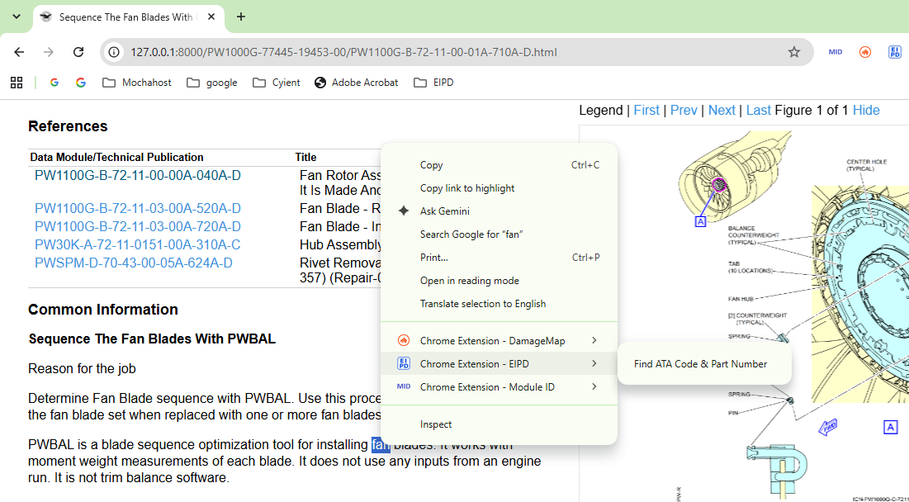

the following output will be shown
